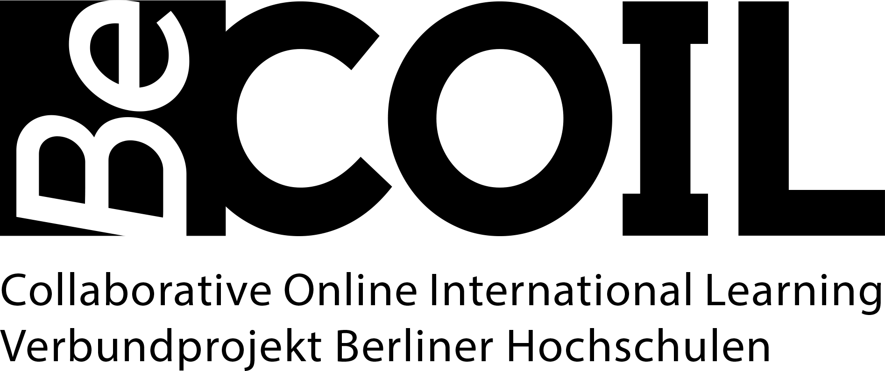

COIL Support and Advice

Implementing COIL programs can be challenging for institutions and educators, especially in terms of tech infrastructure, curriculum development, and cross-cultural communication. Below you can find a range of support services and sources of advice that help will educators overcome the challenges associated with implementing COIL programs.

COIL coordinators at the nine participating universities
✓ Advice on the conceptualization of COILs: potentials, special features, challenges & practical examples
✓ Support in the search for international partners
✓ Advice on platforms and tools
✓ Support with administrative issues
✓ Support in the realization of physical mobilities
✓ Advice on further sources of information

Berlin Centre for Higher Education (BZHL): Advice and job shadowing for educators
Here you will find a range of options, which are conducted either in German or English:
Open teaching consultation: You can pose your individual concerns and questions about your teaching. The consultation can take place online, by phone or on site at the BZHL.
Individual consulting on online teaching / moodle: You will receive individual support with your online teaching and can work out possible solutions to challenges together with an expert.
Teaching innovation project: You will receive advice and support in the development and implementation of innovative teaching projects on site.
Individual teaching visits: Do you feel that you could present yourself even better in your teaching and would like support in doing so? Experienced practitioners at the BZHL will provide hands-on advice.

